**Power System Operation and Control (Open Ended Lab) CLO 2**

**Transient Stability and Power System Dynamics on Medium size systems**

# Background on 37 Bus APL System

As was the case with the previous lab, we’ll start working with the 37bus system modeling the fictional Aggieland Power and Light (APL) grid; its online is shown in Figure 1.

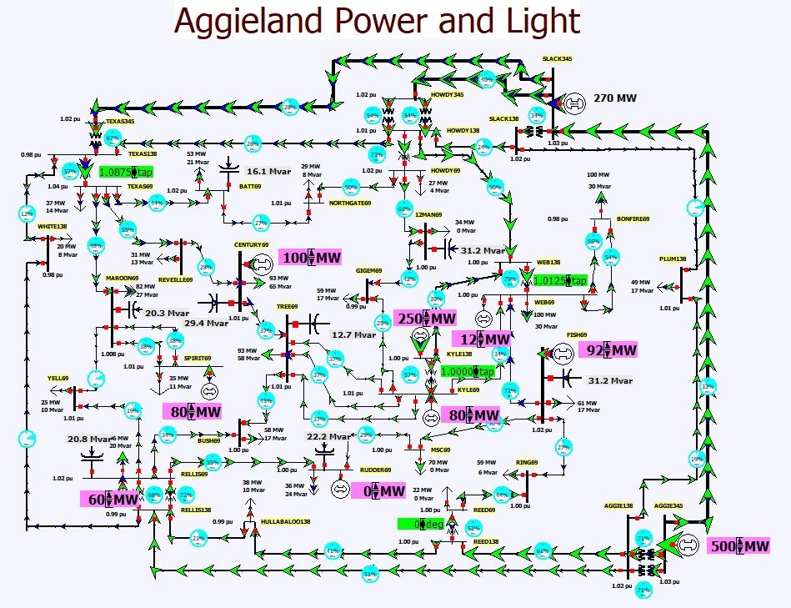

# Figure 1: 37 Bus APL System

# Procedure for Running Transient Stability on the APL System

1. Start PowerWorld Simulator. Open the Lab10_AGL_TS case. The system has been setup to run transient stability with several contingencies predefined for the lab. Select **Add Ons, Transient Stability** to display the Transient Stability form. This will be used throughout the lab to do the transient stability simulations. This is shown in Figure 2.

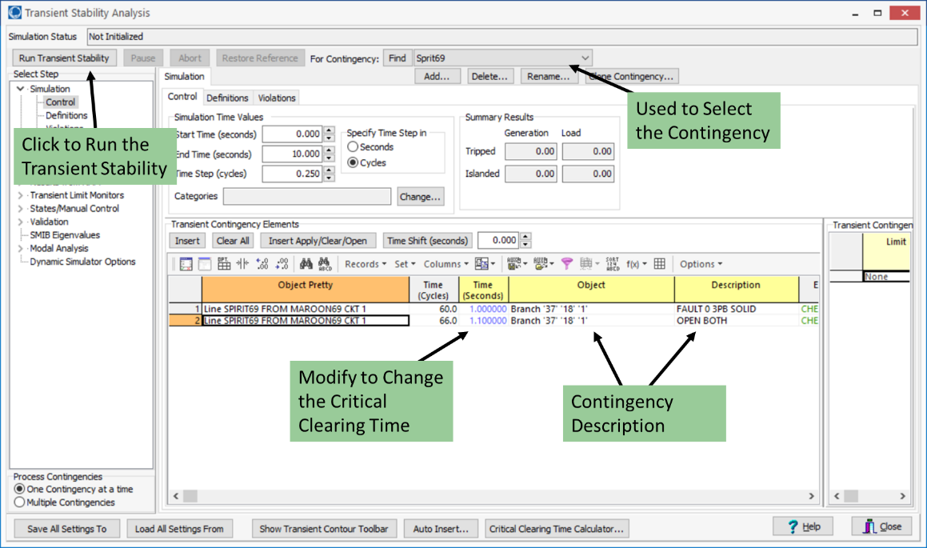

Figure 2: Transient Stability Form

2. For the first transient stability contingency, select the Sprirt69 contingency. This contingency applies a balanced three-phase fault at time equals 1.0 seconds right at the terminal of one of the 69 kV transmission lines going into the Spirit substation. After 0.1 seconds the fault is cleared by opening the transmission line. To do the transient stability run, click on the **Run Transient Stability** button. At the end of the simulation a graph will appear showing the time-varying generator rotor angles. Save a copy of this graph for your report.

3 Iteratively change the time the transmission line is opened to determine the critical clearing time for this fault (to a precision of 0.01 seconds – critical time is defined as the longest time the fault can be applied without one of the generators losing synchronism). The critical clearing time is the time difference between when the fault is applied (i.e., time = 1.0 seconds) and that largest clearing time. Save a copy of the rotor angle graph for the critical clearing time for your report and record the critical clearing time.

4. Change the output of the Sprit69 generator from 80 to 40 MW, and repeat step 3. In your report comment on why such a change result in a different critical clearing time.

5. Re-open the Lab10_AGL_TS case and the Transient Stability Form. Change the contingency to Kyle138, which simulates a fault on the 138 kV transmission line between the Kyle and WEB substations, which is also cleared by opening the line. Again calculate the critical clearing time for this fault, saving a copy of the graph for your report.

6. Next, change the assumed H value for the Kyle138 generator. There are several ways to do this. One is to right click on the generator on the oneline and select **Generator Information Dialog**. On the **Stability, Machine Models** page change the **H** value from 3.0 to 6.0. Select **OK** to save your change and close the dialog. Again, calculate the critical clearing time for the Kyle138 contingency. Did the change in the critical clearing time match your expectations?

**Rubrics of Open-Ended Lab (OEL) CLO2**

|  |  |  |  |  |
| --- | --- | --- | --- | --- |
| Performance  Parameter | Good  (100-80%) | Average  (80-40%) | Below average  (40-0%) | Marks |
| Understanding of the task | Have a complete knowledge about the assigned lab tasks. | Moderate understanding of the experiment. | Does not interpret the assigned tasks and unable to explain it. | [2] |
| Performance | Perfect execution, no bugs in the mathematical work and simulation, completion of the tasks, accurate compilation. | Errors found in the compilation of mathematical work and simulation. | Have no idea about the mathematical calculation, simulation and the operation is substantially wrong. | [5] |
| Report | Submits a lab report on due time. | Submits incomplete lab report on due time. | Submits a copied lab report or submission after due time. | [3] |
| Total |  |  |  | [10] |

* **Simulation & Circuits:**
* **Case 1:** Using Spirit69 Contigency

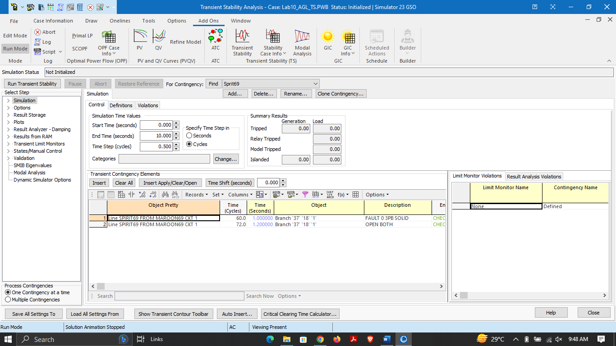

* At 1.2s

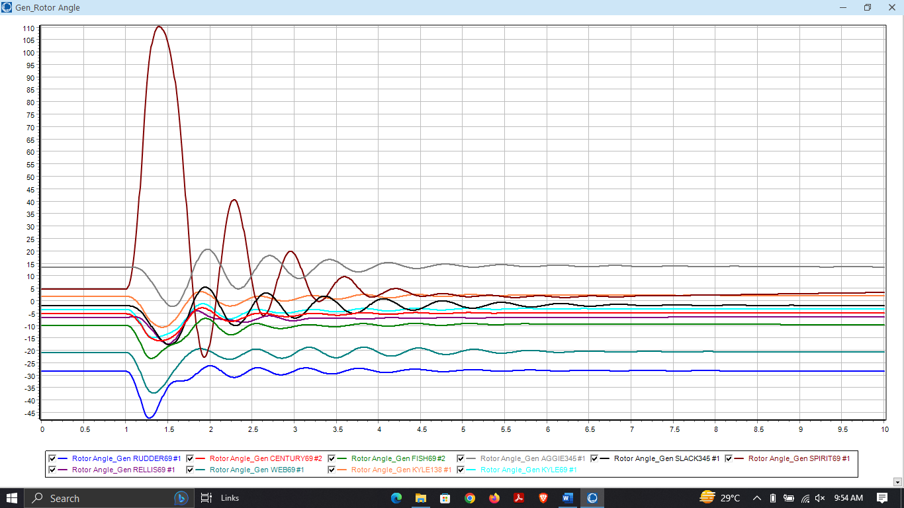

* At 1.21s

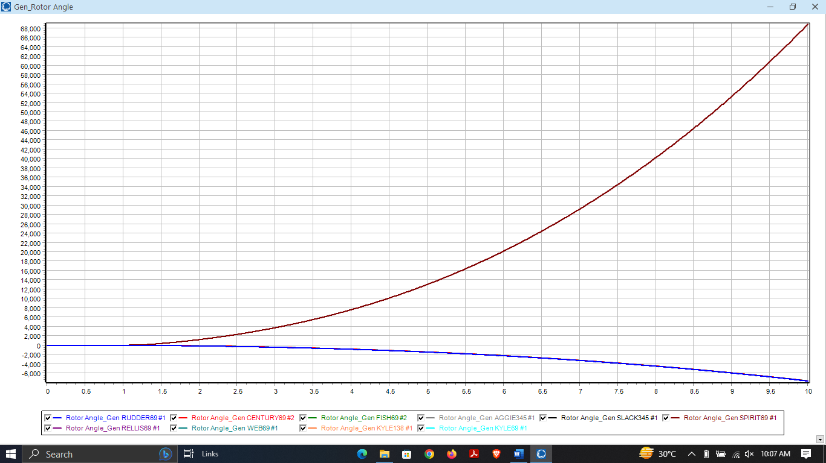

* **Case 2:** Change the output of the Sprit69 generator from 80 to 40 MW

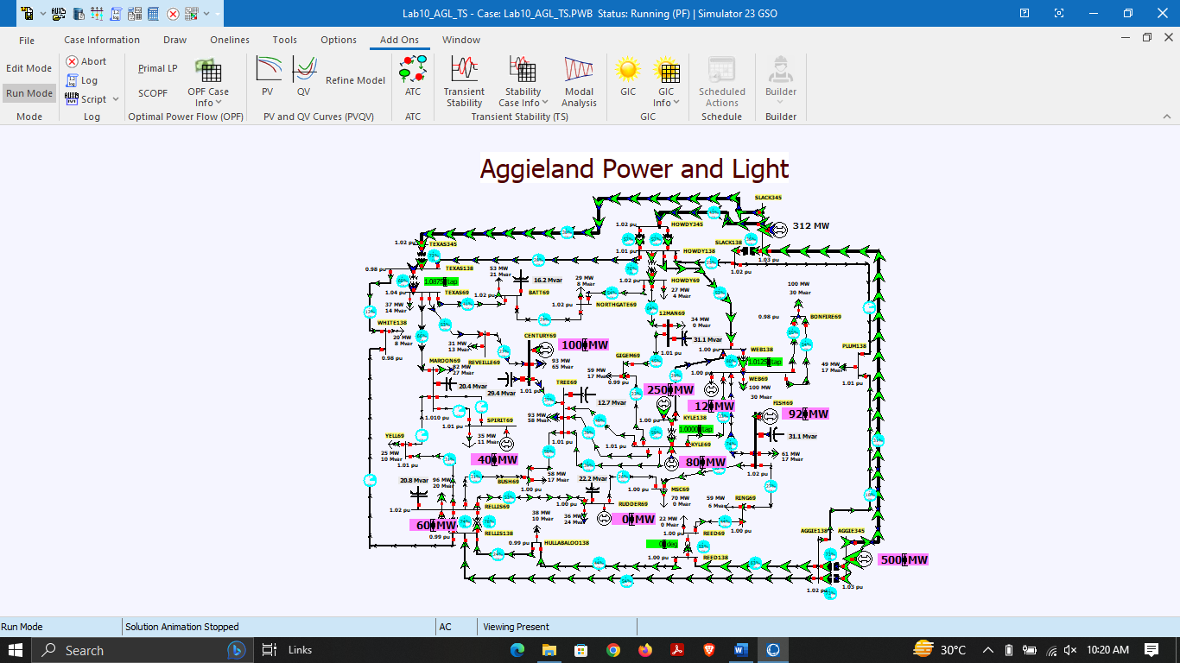

* At 1.38s

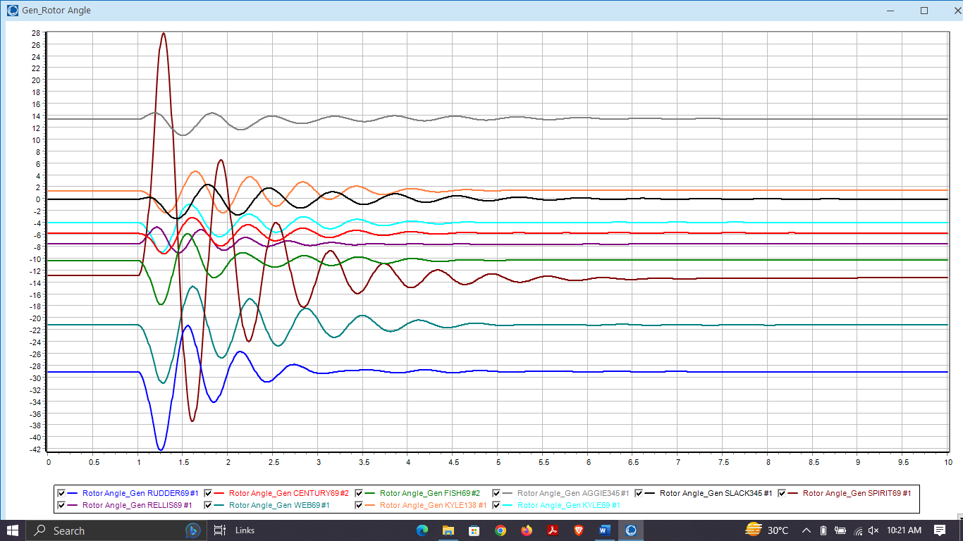

* At 1.39s

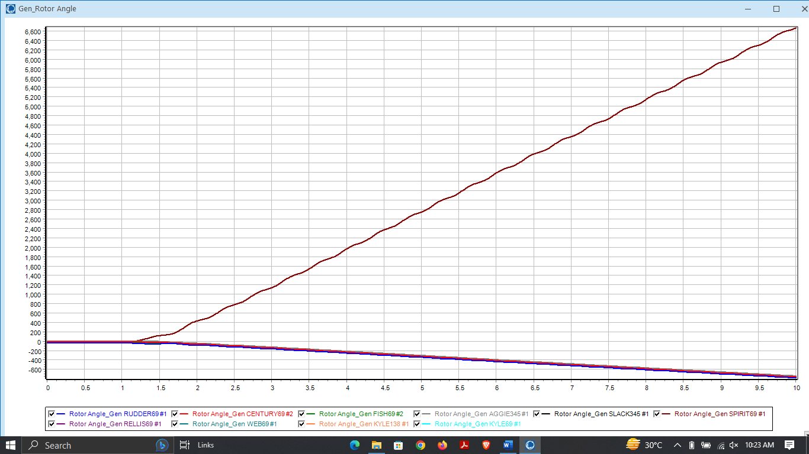

**In your report comment on why such a change result in a different critical clearing time.**

When the output of a generator is reduced, the system becomes more vulnerable to faults, and the critical clearing time will decrease. This is because with lower generator output, there is less available power to counteract the fault, and therefore, the fault must be cleared more quickly in order to prevent instability.

Conversely, when the output of a generator is increased, the system becomes less vulnerable to faults, and the critical clearing time will increase. This is because with higher generator output, there is more available power to counteract the fault, and therefore, the fault can be cleared more slowly while still maintaining system stability.

* **Case 3:** Kyle 138

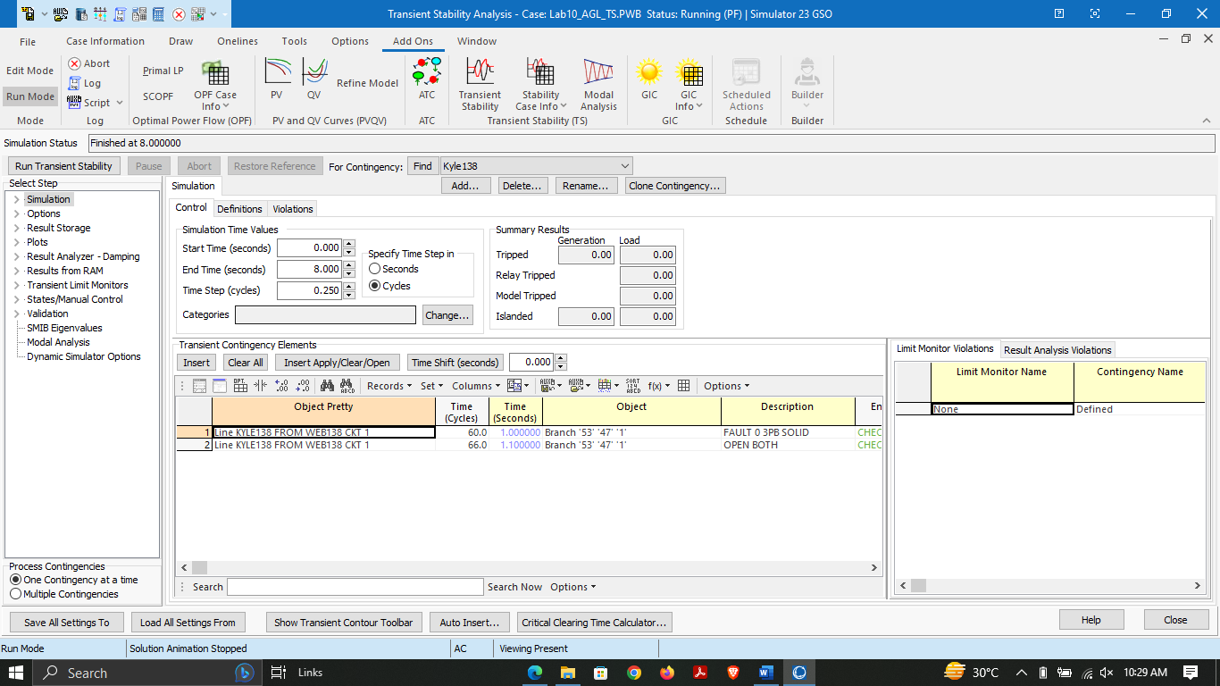

* At 1.22s

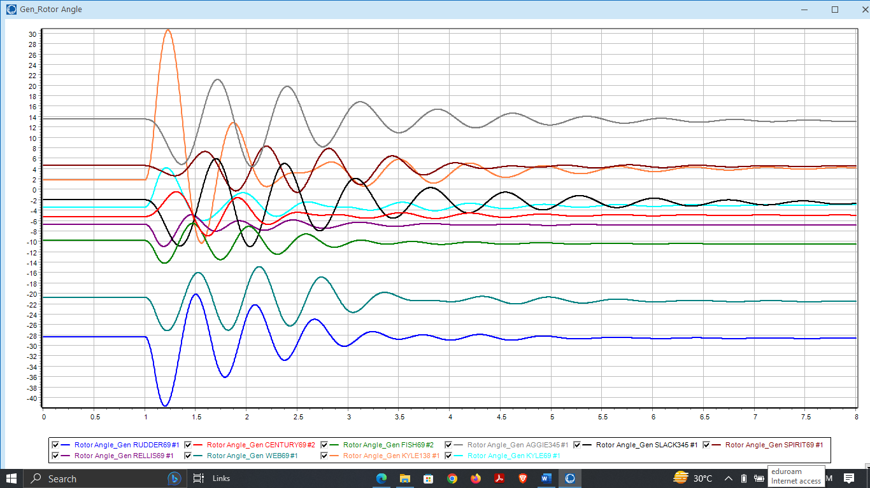

* At 1.23s

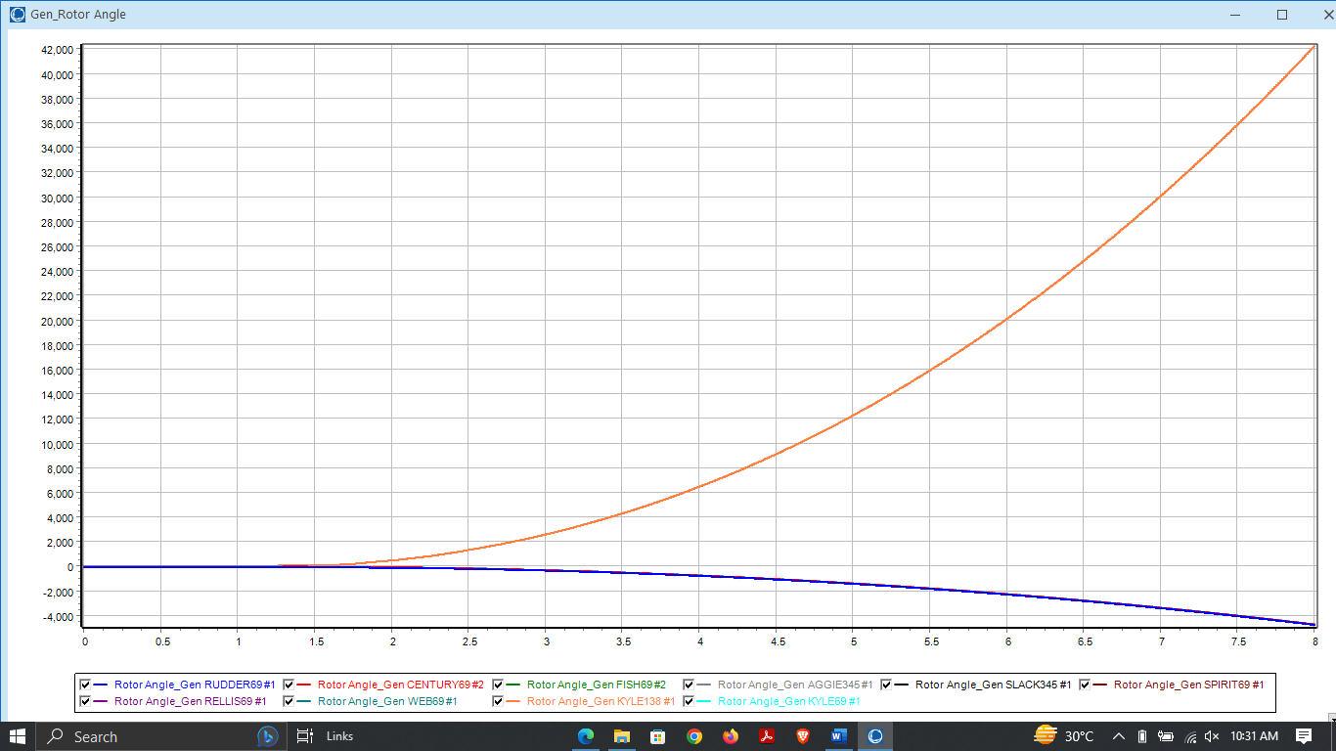

* **Case 4:** Change the assumed H value for the Kyle138 generato (H=6)

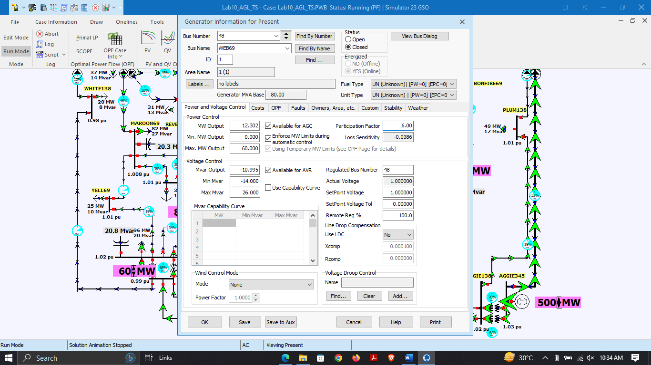

* At 1.31s



* At 1.32s

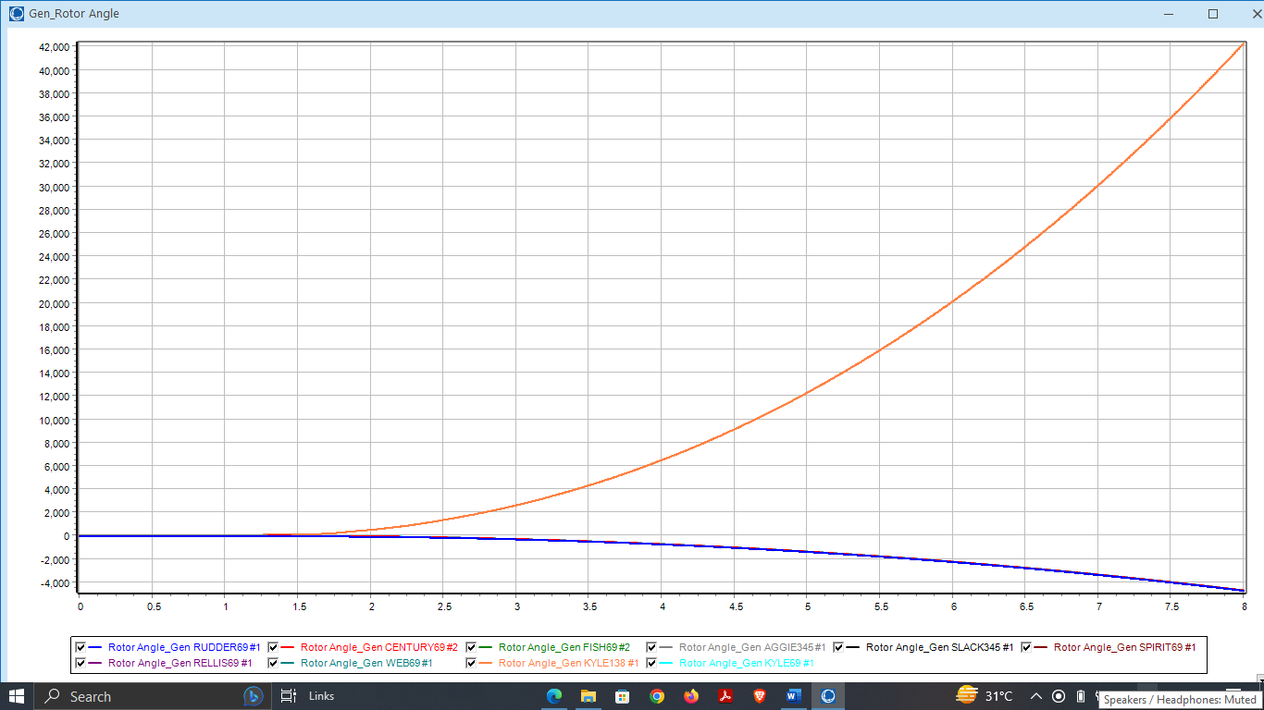

**Did the change in the critical clearing time match your expectations?**

Increasing the value of H (inertia constant) should increase the critical clearing time as it implies that the generator has a larger inertia and can withstand disturbances for a longer duration. Therefore, the expected result was an increase in the critical clearing time for the Kyle138 generator

* **Conclusion:**

Transient Stability and Power System Dynamics on Medium-size systems lab provided a hands-on experience on analyzing and simulating power system dynamics. The lab used the 37 Bus APL system to investigate the effect of faults and contingencies on the stability of the system. The critical clearing time was determined for different contingencies by iteratively changing the time the fault is cleared. It was found that changing the output of a generator and the H value of a generator can significantly affect the critical clearing time.

Through this lab, we were able to gain a deeper understanding of power system dynamics and the importance of maintaining system stability. This lab also provided us with practical experience using PowerWorld Simulator software to simulate power system dynamics. Overall, this lab was an informative and valuable experience that enhanced our knowledge of power system operation and control.